ABOUT THE CONFERENCE
We are immensely happy to announce that in the year 2023, 11th – 12th February, The Indian Association of Physiotherapists, Gujarat Chapter will be hosting the 60th National Conference of The Indian Association of Physiotherapists with the theme “ Workout for Fit India” at Ahmedabad, Gujarat.
Gujarat also called the "Jewel of Western India is a flourishing state with cultural diversity. It is vibrant with its true colors of rich heritage and cultural traditions. Wildlife sanctuaries, hill resorts and natural grandeur are gifts of Gujarat. Sculpture, handicrafts, arts, festivals also make the state rich.
The city of Ahmedabad is endowed with a rich architectural heritage that is vital to the local identity and continuity of the place. Ahmedabad has it all to be the first city in India to be inscribed in UNESCO's World Heritage City list of 2017.
IAP National conference is an annual event. It will be after 16 years, Gujarat will be witnessing this grand event where Physiotherapy delegates nationwide are expected to be present in huge numbers. There will also be International guests from across the globe representing Physiotherapy profession in their countries. The mega event will have various scientific as well as cultural programs which will include the seminars and keynote lectures by international and national speakers, paper and poster presentations. Special Highlight of the Conference is first time ever we are announcing Scientific Presentations (Paper and Poster Presentations) for Clinicians as a separate category. We look forward to larger Clinician Participation.
We are sure that our attempts will bring a change in the community and lead to professional upliftment of our fellow beings.
CONFERENCE VENUE
THE FORUM, Club -07, Shela,Near SP Ring Road Ahmedabad
One of the largest Convention and Conferencing destination qualifying International standards -The Forum Unconventional Unbelievable.
The Forum flourishes over 2,00,000 sq.ft. with an accommodating capacity upto 5,000 guests.
It offers the corporate, an exclusive destination for world class Conferencing and Meeting Rooms ,and a world class Auditorium with top notch acoustics and thus taking the business experience to a whole new level.
Over and above all this, The Forum offers all Corporate different options based on their requirements, while having the uncompromised quality standards wrapped in rich finesse with traditional warmth.
The Forum extends itself to an all 160-All Suite Hotel
To top it all, a parking capacity of about 1500 Cars.
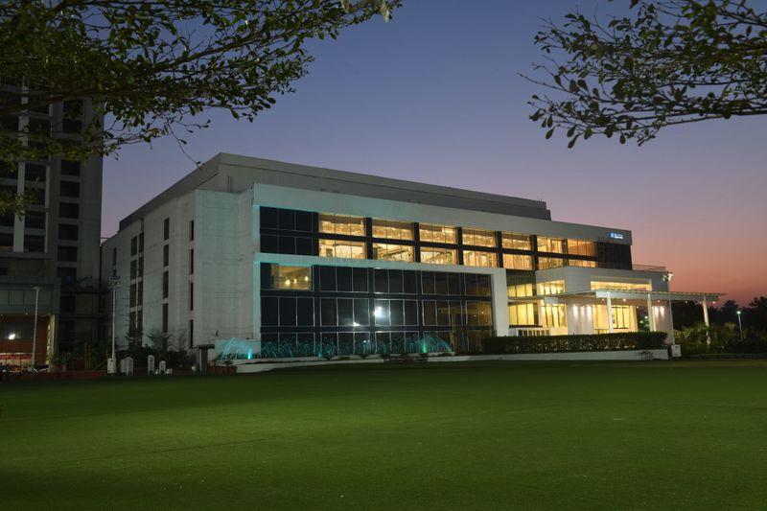

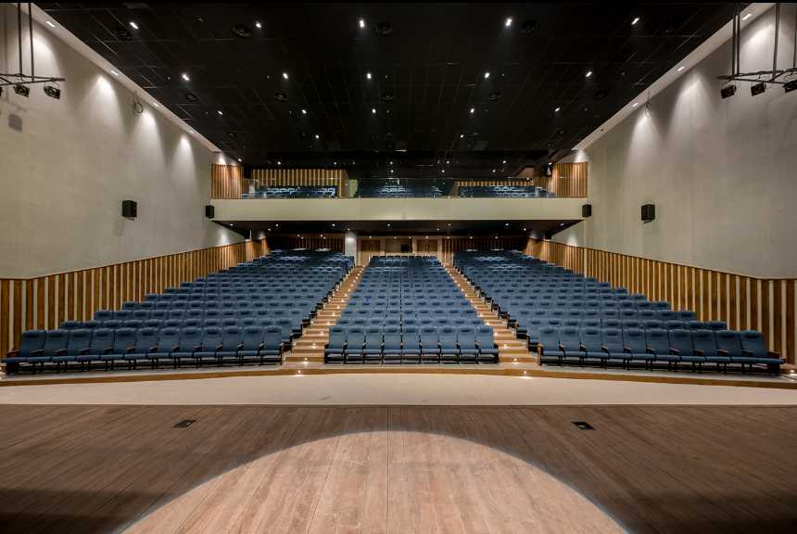
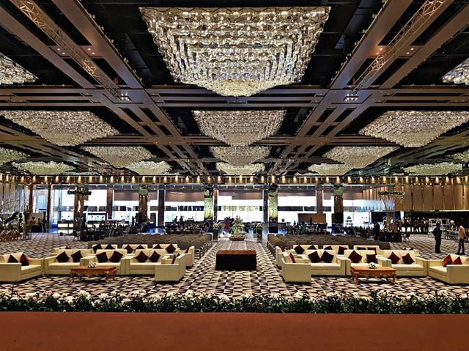
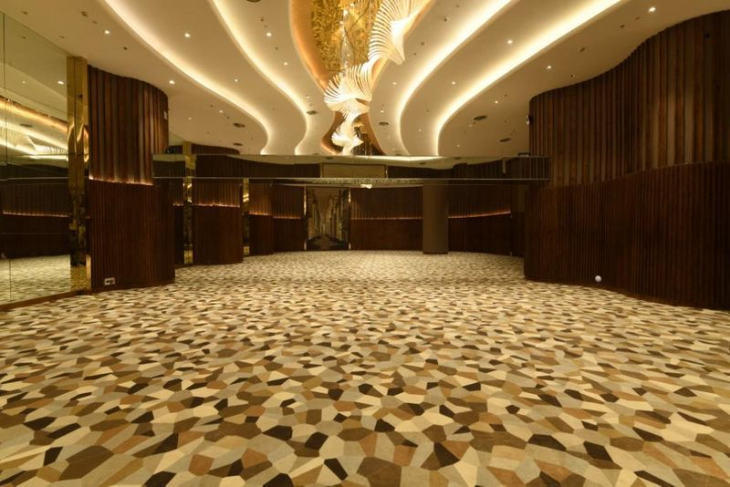
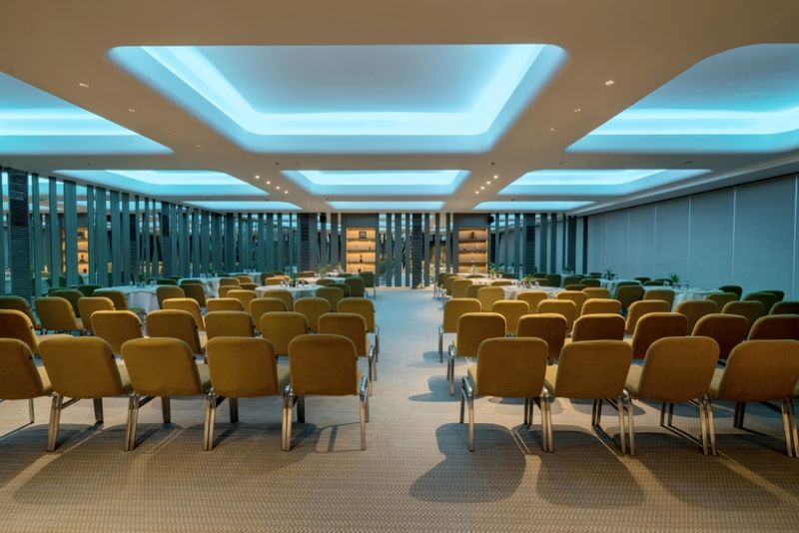

CENTRAL ORGANIZING COMMITTEE | STATE ORGANIZING COMMITTEE
PATRONS - Dr. Neeta Vyas (PT), Dr. Yagna Shukla (PT)
Dr Sanjiv Kr. Jha (PT)  Organizing Chairperson | Dr Nehal Shah (PT)  Organizing Chairperson
Dr KM Annamalai (PT)  Central Organizing Secretary | Dr Dhara Sharma (PT) State Organizing Secretary  Dr Bhavana Gadhavi (PT) and Dr Piyush Patankar(PT)  Joint Organizing Secretary
Dr Ruchi Varshney (PT)  Central Treasurer | Dr Megha Sheth (PT) State Treasurer  Dr Nehalbhai Shah (PT) Joint Treasurer

COMMITTEES AND COMMITTEE HEADS
NAME OF THE COMMITTEE | CENTRAL ORGANIZING COMMITTEE | STATE ORGANIZING COMMITTEE
INTERNATIONAL CO-ORDINATION | Dr Ali Irani (PT)
SCIENTIFIC COMMITTEE | Dr Reshma Khurana (PT) | Dr Shraddha Diwan (PT  Dr Jaspreetkaur Kang (PT)
REGISTRATION COMMITTEE | Dr Sureshbabu Reddy (PT)  Dr Joji Jons (PT) | Dr Bhumika Nayak (PT)  Dr Mihirdev Jhala(PT)
CULTURAL COMMITTEE AND STUDENT FORUM | Dr Mohd Suhail (PT)  Dr Dinesh Samujh (PT) | Dr Urvashi Jhala (PT)  Dr Vaishali Raol (PT)  Dr Riddhi Patel (PT)  Dr Bhavin Desai (PT)  Dr Vivek Ramanandi (PT)  Dr Kalpesh Satani (PT)
AWARDS AND RECOGNITION COMMITTEE | Dr Anjani Kumar (PT)
SPONSORSHIP COMMITTEE | Dr Vivek Jain (PT)  Dr Achal Vashi (PT) | Dr Sagar Naik (PT)  Dr Milesh Pandya (PT)  Dr Ketul Oza (PT)
STALLS AND EXHIBITION COMMITTEE |  | Dr Chandresh Sripal (PT)
SOUVENIR COMMITTEE | Dr Masarat Safi (PT)  Dr Sudeep Kale (PT) | Dr Dinesh Sorani (PT)
RECEPTION COMMITTEE | Dr Uma Sengupta (PT) | Dr Alpa Purohit (PT)
TRAVEL AND ACCOMODATION COMMITTEE | Dr CK Senthilkumar (PT)  Dr Rishi Raj (PT) | Dr Gaurav Patel (PT)  Dr Edrish Contractor (PT)
MULTIMEDIA AND IT COMMITTEE |  | Dr Sarfaraznawaz Shah (PT)

SCIENTIFIC PRESENTATIONS
SCIENTIFIC SECTION
The scientific Committee invites you to submit Abstracts of research reports/Case Studies /new or improved therapeutic procedure for the 60th IAP National Conference, 2023 at Ahmedabad as platform/ Poster presentation.

CALL FOR ABSTRACT PAPER
It is mandatory to register for 60th IAP National Conference 2022 for selection and presentation.
CATEGORIES FOR PRESENTATION
- UNDERGRADUATE CATEGORY - BPT Students.
- POSTGRADUATE CATEGORY - MPT Students.
- PROFESSIONAL CATEGORY
- JUNIOR PROFESSIONAL CATEGORY - Professionals who have less than or equal to 5 years teaching/clinical experience after BPT or professional who have 3 years teaching/ clinical experience after MPT.
- SENIOR PROFESSIONAL CATEGORY - Professionals who have more than 5 yearsteaching / clinical experience after BPT or professional who have more than 3 years teaching/ clinical experience after MPT.
General Guidelines for Abstract Paper Submission :
Kindly read the following points carefully
- Abstract should be limited within250 words (excluding the title).
- Papers should focus on Physiotherapy research only.
- The Research topic should not have been presented / published at any scientific meeting / journal before.

Subheadings that needs to be included in the abstract during online submission:

- Title of Abstract
- Authors (Full name, title, affiliation, city and state of presenter and all co-authors should be included). Name of the presenting author should be underlined. Presenting author/corresponding author should provide email id, contact number and official address
- A completed abstract with structured format should include;
1. Background and need of research
2. Methods
3. Result
4. Conclusion and Clinical Implications
5. Key-words
6. Funding acknowledgement
7. Ethic’s approval (wherever required)
8. Word limit: 250 words (excluding the title)

- Rules and regulations for paper/ poster presentation
- It is mandatory to register for 60th Annual Conference of IAP
- A code will be assigned to the submitter of the abstract for paper presentation at the time of acceptance of the abstract and code will be your identity for any official scientific communication.
- TIME FOR PAPER PRESENTATIONS is 8+2 minutes (8 minutes for presentation and 2 minutes for question answer session).
- Paper presentation should be in MS Power Point format (limit to 10-15 slides).
- First slide should be with title and registration number. Final presentation should not reveal identity of any author or the Institute / Hospital.
- Succeeding slides must have heading and maximum of 6 lines per slide. Slide number should be mentioned
- Can include subtitles such as need for the study/review, methodology, results, discussion, conclusion etc.
- References need not be included. If required, it will be asked during the question hour
- Reviewers of the abstract have all rights to accept / reject the paper for presentation during the conference and presenters will be intimated well in advance.
- Judge’s decision shall be final and abiding
- Certicate will be issued to the presenting author only.
- The presenting author is required to ensure that all co- authors are aware of the content of the abstract before submission.
- Each author can submit and present only a maximum of 2 abstracts.
- Same abstract cannot be used for both paper and poster presentations
- Send in your entries to https://app.oxfordabstracts.com/stages/5006/submitter and make sure you put your category of presentation on/before 15th December , 2022

CALL FOR ABSTRACT OF E-POSTER
CATEGORIES FOR PRESENTATION
- UNDERGRADUATE CATEGORY - BPT Students.
- POSTGRADUATE CATEGORY - MPT Students.
- PROFESSIONAL POSTER CATEGORY- BPT / MPT Professionals.
Specific Guidelines of Abstract of E- Poster Submission:
- It is mandatory to register for 60th Annual Conference of IAP
- For PG and Professional category, it is mandatory to have a research based poster. Simple narratives will not be permitted for PG and Professional category.
- For UG category, poster can have a Physiotherapy research performed by UG student under guidance or can have any topic pertaining to research.
- A code will be assigned to the team for poster presentation at the time of acceptance of the abstract.
- TIME FOR POSTER PRESENTATIONS is 5+2 minutes (5 minutes for presentation and 2 minutes for question answer session).
- Slight modification which does not change the idea of the abstract is allowed
General Guidelines for Abstract Poster Submission :
Kindly read the following points carefully
- Abstract should be limited within250 words (excluding the title).
- Papers should focus on Physiotherapy research only.
- The Research topic should not have been presented / published at any scientific meeting / journal before.

Subheadings that needs to be included in the abstract during online submission:

- Title of Abstract
- Authors (Full name, title, affiliation, city and state of presenter and all co-authors should be included). Name of the presenting author should be underlined. Presenting author/corresponding author should provide email id, contact number and official address
- A completed abstract with structured format should include;
1. Background and need of research
2. Methods
3. Result
4. Conclusion and Clinical Implications
5. Key-words
6. Funding acknowledgement
7. Ethic’s approval (wherever required)
8. Word limit: 250 words (excluding the title)

- Please submit your final Poster as a single page in portrait or landscape orientation.
- File format: PDF or .ppt
- It is recommended to make your poster in PowerPoint (Landscape or Portrait) and then save it as a PDF or JPEG (E-Poster size in cm: 38 width x 54 height – portrait orientation)
- Font size: ≥16
- Top of the Poster should display the following information: Title of your Paper, Code No., Times New Roman (Bold, Font Size: 18)
- Ensure enough contrast between color of text and background of poster

- Try to keep the text concise and easy to read
- The poster must have a clear message, logical layout and should be easy to comprehend
- Avoid use of full sentences, rather use short text in bullet point format.
- Avoid using watermarks that may detract from the readability of your poster.
- Illustrations are the most important part of the poster and will attract most attention.
Colorful charts and graphs are the easiest ones to convey information.
- Explanatory illustrations should be used instead of text whenever possible.
- Use only static images and do not embed any videos or animation in your poster.
- Try to utilize the space on your poster as creatively as you can to attract the audience and make sure that the images are easy to understand
- Send in your entries to https://app.oxfordabstracts.com/stages/5006/submitter and make sure you put your category of presentation on/before 15th December, 2022

CLINICAL CASE/CASE SERIES PRESENTATION
IAP encourages all physiotherapist Exclusively Working in Clinical Field to submit Clinical cases/case series for the Conference. This is a great opportunity to share your experiences and have case presentation in front of key opinion leaders in the field and actively contribute to the physiotherapy Fraternity based on practice based research.
- JUNIOR PROFESSIONAL CATEGORY - Professionals who have less than or equal to 5 years of clinical experience.
- SENIOR PROFESSIONAL CATEGORY - Professionals who have more than 5 years clinical experience.

RULES & REGULATIONS

Abstract should be well organized and should not exceed 250 words (excluding title). Abstract title (limited to 20 words) should be given in upper case bold letters.The title should present the case without suggesting any diagnosis.
- First slide should display the following information: Title of your Paper, Code No., Times New Roman (Bold, Font Size: 18)
- The abstracts for case study / case series should be in the format of- Identification data of the patient, presenting complaints, history, examination findings, investigations, differential diagnosis, treatment, follow-up , clinical conclusion and references.Identity of the Patient/s must not be revealed.
- The submitted clinical cases need to be educationally relevant and not necessarily rare or unusual.
- The abstract submitted should not have been presented / published elsewhere.
- When preparing cases for submission(final), please structure submissions under the following sections: Background and Reason for Presenting the Case, Demographics of Patient, Key findings, , Interventions and Plans/Prognosis.
- Each participant will be provided five minutes for presentation (including video) followed by 2-3 minutes discussion
- Prior to submission/Presentation, you are solely responsible for removing any elements that could be used to identify patients and follow ethics.
- Abbreviations should be defined, please use full names.

- Selection Criteria
- The abstracts will be reviewed based on the scientific values and clinical implications. All decisions made by the Academic & Scientific Committee will be final.
- Incomplete study will not be accepted
- Send in your entries to https://app.oxfordabstracts.com/stages/5006/submitter and make sure you put your category of presentation on/before 15th December, 2022
- Committee reserves right to accept or reject the abstract and decision of the committeewill be final.
- It is mandatory to register for 60th IAP National Conference 2022 for selection and presentation.

INNOVATIONS IN PHYSIOTHERAPY WITH ENTERPRENEURIAL FOCUS
The roles of physiotherapists have grown exponentially over the years, with improved diagnostic and decision making skills. With this many newer avenues have opened up for the physiotherapist to excel differently in the market. Independent contracting and being your own boss is becoming increasingly popular. We can see a number of leaders and budding entrepreneur who have followed their dreams and who have begun or making leaps in the field from being a physical therapist to entrepreneur and business owner, thus creating a newere vision and mindset to the profession.
The 60th IAP take an initiative to showcase such talents to encourage not only them but the budding generations to pave new ways in the profession.
- Kindly send a short summary of your entrepreneurial model in 500 words in the following format
- The summary should include Background information/ Problem statement in the market;Physiotherapy solution/ Model; The vision, goals and objectives; Challenges faced;Progress/ results
- During the final presentation you will be allotted 5 min for presentation and 2 minutes for questions sessions.
- Presentation need to be made in Microsoft Power point with relevant details, photographs or videos etc.
- Who can participate - practicing physiotherapists (clinicians or academicians) with unique solution to current issues in physiotherapy fraternity
- Send in your summary on scientificiap60@gmail.com. Make sure to make the subject of your email as “Summary for innovations in Physiotherapy”

GENERAL INSTRUCTIONS FOR ALL CATEGORIES
LAST DATE OF ABSTRACT SUBMISSION –15th December, 2022
AUTHOR NOTIFICATION –10th January, 2023.

For any querries kindly feel free to mail us:
scientificiap60@gmail.com
Central Scientific Convenor Dr.Reshma Khurana (PT)
Scientific Convenor
Dr. Shraddha Diwan (PT)–Mob:9824264617
Dr. Jaspreet Kaur Kang (PT) - Mob:9429129409

SPONSORSHIPS AND ADVERTISEMENTS - STALLS

SR. No. | STALL SIZE | DETAILS | COST  (Upto 30th November,2022)  (Rs) | COST (After 30th November, 2022)  (Rs)
1 | 4m* 3m | 3 person allowed with lunch, Branding in prime location, 2 standee inside auditorium 2 standee within the stall | 220000/- | 3,00,000/-
2 | 3m*3m | 2 person allowed with lunch, Branding 2 standee within the stall | 120000/- | 2,00,000/-
3 | 2m*3m | 1 person allowed with lunch, Branding | 70000/- | 1,20,000/-

SOUVENIR
SR. NO. | DETAILS | COST  (Upto 30th November,2022)  (Rs) | COST (After 30th November, 2022)  (Rs)
1 | BACK COVER | 55000/- | 65000/-
2 | FRONT INSIDE COVER | 50000/- | 60000/-
3 | BACK INSIDE COVER | 50000/- | 60000/-
4 | FULL PAGE (COLOUR) | 30000/- | 40000/-
5 | FULL PAGE (BLACK & WHITE) | 15000/- | 25000/-
6 | HALF PAGE (COLOUR) | 10000/- | 20000/-
7 | HALF PAGE (BLACK AND WHITE) | 7500/- | 12000/-

BANNER
SR. NO. | DETAILS | COST  (Upto 30th November,2022)  (Rs) | COST (After 30th November, 2022)  (Rs)
1 | BANNER (STANDEE ONLY) | 15000/- | 25000/-

SESSION SPONSORSHIP
SR. NO. | DETAILS | COST  (Upto 30th November,2022)  (Rs) | COST (After 30th November, 2022)  (Rs)
1 | 15 MINUTES TALK | 30000/- | 40000/-
2 | 30 MINUTES TALK | 55000/- | 65000/-

PRIME SPONSORSHIP
SR. NO. | DETAILS | COST  (Upto 30th November,2022)  (Rs) | COST (After 30th November, 2022)  (Rs)
1 | Event Partner  Stall 4 mt x 3 mt (Premium Category) Lunch/ Free Registrations for 5 persons, Branding in every advertisement of conference. Banner in conference hall. Brochure in the kit , souvenir colour page advertisement. 20 minute session in the Hall. | 1700000/- | 2300000/-
2 | Platinum Sponsorship  Stall 4 mt x 3 mt (Premium Category) Lunch for 4 person branding in every advertisement of conference. Banner in conference hall. Brochure in the kit , souvenir colour page advertisement. 15 minute session in the Hall. | 1500000/- | 2000000/-
3 | Diamond Sponsorship  Stall 4 mt x 3 mt (Premium Category) Lunch for 3 person branding banner in the conference venue Brochure in the kit, souvenir colour page advertisement. 15 minute session in the Hall. | 1200000/- | 1700000/-
4 | Gold Sponsorship  Stall 4 mt x 3 mt (Premium Category) Lunch for 3 person branding banner in the conference venue. Brochure in the kit, souvenir B/W page advertisement. | 1000000/- | 1500000/-
5 | Special Sponsorship in the following categories  Academic Partner, Scientific Partner, Knowledge Partner, Clinical Partner, Cultural Partner, Hospitality Partner  Free registration for 5 persons from your end, branding banner in the conference venue, souvenir B/W page advertisement | 500000/- each | 800000/-
*GST Extra in all categories

CULTURAL EVENTS
The cultural committee invites you to submit the entries for the cultural events.
REGISTRATION FOR CULTURAL EVENTS
It is mandatory to register for 60th IAP National Conference 2023 for selection and participation.
CATEGORIES FOR PARTICIPATION
1. GROUP DANCE - BPT/MPT STUDENTS
2. FASHION SHOW - BPT/MPT STUDENTS
3. SOLO/ GROUP DANCE - PHYSIOTHERAPY PROFESSIONALS
4. SOLO/ GROUP SINGING - PHYSIOTHERAPY PROFESSIONALS
GENERAL GUIDELINES FOR CULTURAL EVENTS
- Preliminary rounds of each categories will be conducted on 10th February, 2023
- Best 3 performances will be selected for each category for performance in the Cultural Evening of the conference
- Details of preliminary round will be sent to the participants well in advance
- Participants must be present on the given date and venue for the preliminary round
- Music for Dance and Fashion show must be sent latest by 15th January, 2023
- Last date of registration for the cultural events is 15TH December 2022
RULES AND REGULATIONS FOR GROUP DANCE (ALL CATEGORIES)
1. Only one entry per college is allowed
2. Maximum time limit for dance is 5 minutes
3. Maximum 5 - 12 participants will be allowed in the performance
4. Dance performance should not convey any indecent gestures
5. The teams will be judged on the basis of their rhythm, formation, synchronization, expression, costume, makeup, theme and overall effect
6. Decision of the judges will be final and binding
7. For the registration click on the given link https://docs.google.com/forms/d/1uA3qtpaEonvtaNpktfNL_3S-HEO0i9LEEJY13lwnl74/edit

RULES AND REGULATIONS FOR SOLO DANCE (ONLY FOR PHYSIOTHERAPY PROFESSIONALS)
1. Maximum time limit for dance is 3 minutes
2. Dance performance should not convey any indecent gestures
3. The participants will be judged on the basis of their rhythm, formation, synchronization, expression, costume, makeup, theme and overall effect
4. Decision of the judges will be final and binding
5. For the registration click on the given link
https://docs.google.com/forms/d/10LxCjzO5Jr3LkTqZf3JtYoZNGO3fJo2k9NN7bMmKtkA/edit

RULES AND REGULATIONS FOR SOLO SINGING (ONLY FOR PHYSIOTHERAPY PROFESSIONALS)
1. Maximum time limit for singing is 3 minutes
2. Participants must carry necessary things to be used during the performance and provide the music of their song well in advance
3. The performance will be judged on the basis of song selection, voice quality, clarity, rhythm and appeal to the audience
4. Choice of song is open to the participant but the song should not have any slang or derogatory language
5. Decision of the judges will be final and binding
6. For the registration click on the given link
https://docs.google.com/forms/d/10LxCjzO5Jr3LkTqZf3JtYoZNGO3fJo2k9NN7bMmKtkA/edit

RULES AND REGULATIONS FOR GROUP SINGING (ONLY FOR PHYSIOTHERAPY PROFESSIONALS)
1. Maximum time limit for singing is 3 minutes
2. Maximum 10 participants will be allowed in performance
3. Participants must carry necessary things during the performance and provide the music of their song well in advance
4. The performance will be judged on the basis of song selection, voice quality, clarity, rhythm and appeal to the audience
5. Choice of song is open to the participant but the song should not have any slang or derogatory language
6. Decision of the judges will be final and binding
7. For the registration click on the given link
https://docs.google.com/forms/d/1cc_TS1zxbzGwWdp6HZz9FrA63cWh1jv3DPii2OP3ovQ/edit

RULES AND REGULATIONS FOR FASHION SHOW
1. Only one entry per college is allowed
2. Maximum time limit for fashion show is 7 minutes
3. Maximum 15 participants are allowed in the performance
4. Fashion show should not convey any indecent gestures
5. The teams will be judged on the basis of their rhythm, formation, synchronization, expression, costumes, makeup, theme and overall effect
6. Decision of the judges will be final and binding
7. For the registration click on the given link
https://docs.google.com/forms/d/e/1FAIpQLSdzyh_XPqJkvMOywjczeN1kVkjAz8zZ8-ccllmb99rSg7YhtA/viewform?usp=sf_link

GENERAL INSTRUCTION FOR ALL CATEGORIES
- Last date of registration of Cultural events - 15th December 2022
- Preliminary round – To be announced soon
- For any further queries feel free to mail us on - culturaliap60@gmail.com

- THEME FOR GROUP DANCE - WORK OUT FOR FIT INDIA
- THEME FOR FASHION SHOW - SOCIAL MESSAGE/COMMUNITY AWARENESS

STUDENT FORUM EVENTS
The student forum committee invites you to submit entries for the student forum events. The event is only for undergraduate students.
FOLLOWING EVENTS ARE INCLUDED IN STUDENT FORUM
- QUIZ COMPETITION
- ESSAY COMPETITION
- DEBATE
- SCIENTIFIC MODEL PRESENTATION
- VIDEO REELS
- PHYSIO CHARADES
REGISTRATION FOR STUDENT FORUM EVENTS
It is mandatory to register for 60th IAP National Conference 2023 for selection and participation.
RULES AND REGULATIONS FOR EACH EVENT
- QUIZ COMPETITION:

- Maximum one team per college is allowed with maximum of four participants the team.
- It is mandatory to take the participants from different academic years in each team.
- Pre-qualifing round will be taken on 10th February, 2023 and top five teams only will enter the final rounds for quiz on 11th February, 2023.
- To participate fill the google form before 15th December, 2022 https://forms.gle/9hhJk7cfvREPAYnc6

- ESSAY COMPETITION:

- THEME OF THE ESSAY: MANIFESTING ADVANCED PHYSIOTHERAPY
- Only undergraduate students can participate.
- Word Limit - Maximum 350 words.
- It is mandatory to register for 60th IAP National Conference 2022 for selection and presentation.
- All Essays should be submitted in clear English with accurate grammar and spelling of a quality suitable for publication.
- Plagiarism Check will be done for the submitted essays.
- Writer’s name and his / her conference registration number should be mentioned clearly top of page and underlined and bold.
- Essay must be in Times New Roman fonts with font size 12. There should be single spacing in the essay only.
- Announcement of the winner will be done during the 60th National Conference of IAP at Ahmedabad.
- Last date of submitting the essay is 31st December, 2022
- To participate fill the google form https://forms.gle/wvEVNHx5C2twQhWb8
- Send your essay to studentforumiap60@gmail.com

- DEBATE:

- Maximum two teams per college will be allowed with a maximum of two participants in each team.
- Time allotted for each team is 7 min.
- Topic of the debate will be given during the event
- To participate fill the google form before 15th December, 2022 https://forms.gle/QrjwsLZmfkXpVt9BA

- SCIENTIFIC MODEL PRESENTATION
  - Model should be based on Physiotherapy related topic.
  - To participate fill the google form and send in your entried before 15th December, 2022
https://forms.gle/ytAbz2msmiBC64HAA

- VIDEO REELS:

- Reels length can be of 30 seconds, mp4 format
- Minimum 1080P and 4K if available (note: video will be capped at 720p after upload)
- Upload aspect ratio 9:16 (iOS) and screen aspect ratio of your device (Android)
- Can add captions
- Reels are based on conference theme “Workout for Fit India” only
- To participate fill the google form https://forms.gle/ecEQJ9jA49PsVAgR8
- Please submit the reels on studentforumiap60@gmail.com latest by 15th December.
- These reels will be put on social media platform of The Indian Association of Physiotherapists and will be judged by viewers only.

- PHYSIO CHARADES:

- Maximum one team per college with a maximum of four participants.
- Any physiotherapy-based topic will be given to one member and he/she must explain that topic through acting and the other members will have to identify the topic.
- Student is not allowed to talk and is required to act out the name by using different gestures, facial expressions and body language.
- Based on Physiotherapy only.
- To participate fill the google form and send your entries before 15th December, 2022
https://forms.gle/mVRMyHKar2i1iyMQ6

GENERAL INSTRUCTIONS FOR ALL EVENTS
- Last date of registration of student forum events – 15th December 2022
- Please fill and submit Google form with submission of required information of the respective category to participate
- Names once given for participation will not be replaced
- For any further queries feel free to mail us on studentforumiap60@gmail.com

TO REGISTER FOR THE CONFERENCE PLEASE CLICK HERE
(Link of pdf to be put which is shared as an attachment in the email)

